Faculty Profile
BENGALI
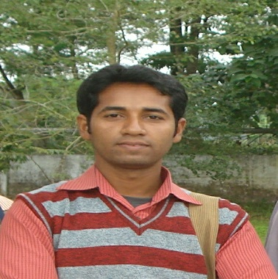

Name: SAUGATA BAGCHI
Designation: Govt. Appv. PPT
Teaching Areas: Poetry, Novel, Linguestic
Research Interest: Bangla Sahitye Flok
Education: M.A
Scholarship/Awarrd/Fellowship etc: N/A
Professional Experience: 5 years(approx) since 25/08/2010 in South Malda College, Pubarun, Malda
Teaching Research: N/A

Faculty Profile

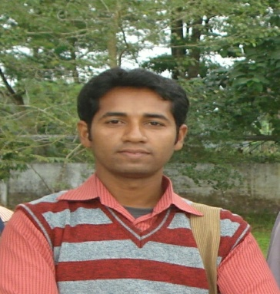

Name: SAUGATA BAGCHI
Designation: Govt. Appv. PPT
Teaching Areas: Poetry, Novel, Linguestic
Research Interest: Bangla Sahitye Flok
Education: M.A
Scholarship/Awarrd/Fellowship etc: N/A
Professional Experience: 5 years(approx) since 25/08/2010 in South Malda College, Pubarun, Malda
Teaching Research: N/A
No. Of sememiners/Symposia/Workshops/Conferences conducted:
No. Of sememiners/Symposia/Workshops/Conferences attended:

